Information Retrieval (CMSC 476/676)

Homework 1 – Report
Done by – Anushka Dhekne (CMSC VD19739)

The objective of this assignment was to design a program to tokenize and down case all words in a collection of HTML files and produces 3 things – a directory containing all the tokenized files (one output file per input file), a file of all the tokens and their frequencies sorted by token and a file of all the tokens and their frequencies sorted by frequencies. I have used Python programming language to complete this assignment and used Visual Studio Code as the code editor. The program written thus, is a HTML document tokenizer code, which parses, tokenizes and process the documents to give the output as mentioned above. Parsing, in context of programming languages means to analyzing the structure of data or text grammatically and extracting meaningful information from this textual data to understand its structure. Tokenizing is the process of breaking down text into smaller or simpler parts like words, digits, or symbols for better analysis. These smaller parts are called tokens.
I have worked with Saiteja Challa (CMSC JA52979) for the implementation of Homework 1. I have imported several Python libraries to parse, tokenize, and process the documents to give the final output. The program processes HTML files and uses the ‘NLTK’ library for tokenization, the ‘BeautifulSoup’ library for parsing, the ‘argparse’ library for command line arguments and the ‘os’ library for file operations to name a few. The code handles punctuations, digits, and all non-alphabetic characters in the HTML files efficiently. It uses regular expressions (the ‘re’ library) for that. Along with the removal of digits and non-alphabetic special symbols like underscores, hyphens, exclamation marks and so on, it ensures that spaces between 2 words is retained in the files. The ‘os’ library is used for file operations while opening files, reading them, writing to those files and generate new ones as well. I have used looping through all the documents in the input directory using the read mode and writing to the files in the output directory using write mode.
Frequencies or counts are calculated using the ‘Counter’ class from the ‘collections’ module, which is used to count the frequency of each word in each parsed input file. When the data from the input file is tokenized and the tokens are converted to lowercase, the frequency counting starts, where each word and each token is also counted. I have used a dictionary-like object to store all the frequency counts, where keys are the words or the tokens whose frequency is to be calculated and values are the actual counts of these frequencies.
This program effectively removes all the punction marks, special characters or symbols and the HTML tags and comments from the input HTML files. It handles the <script> tags of the HTML files correctly and tokenizes the data effectively. It can recognize between text content and the content between HTML tags.
The code shows two output graphs, drawn using the ‘matplotlib’ library. The first line graph is for the Number of Documents processed vs Elapsed Time (in seconds) – which is shown in Blue Color. This plot is displayed as a pop-up window on the screen. Once this window is closed, we see the next line graph - Number of Documents processed vs CPU Time (in seconds) – which is shown in Orange Color. Once this window is closed, we see the result on the terminal itself, which shows two things – Total Elapsed Time to process all the HTML documents and the Total CPU Time to process all the HTML documents. Elapsed time is the total required to process the documents and any more time required for I/O operations or time required in waiting for these operations. CPU time is simply the time required to process the documents.
The screenshots of the outputs are shown below.

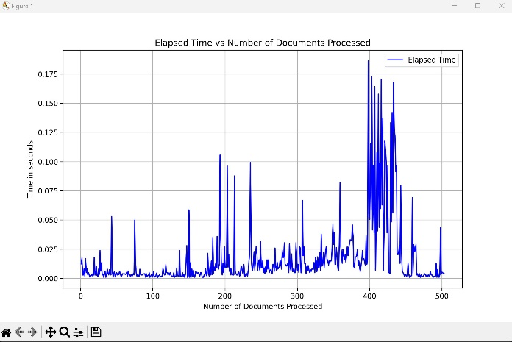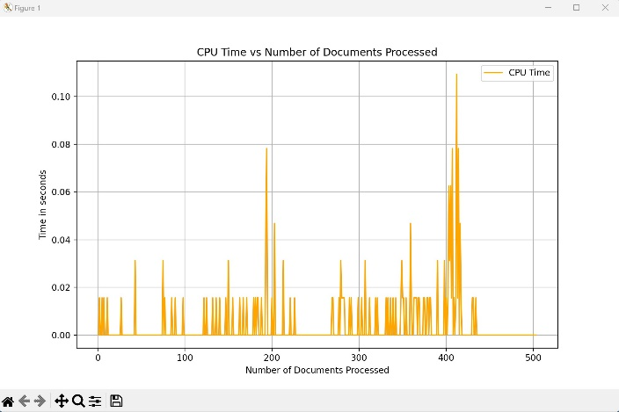

The graphs shown above clearly provide a visual representation of the time taken by each set of 100 HTML documents to be processed and how it varies. For the first graph (blue), we can see that initially, with a few fluctuations the time required for each of the documents to get processed was not more than 0.05 second till around 180 documents, after which the time taken by each document to get processed went up to 0.1 seconds. The time taken for processing again dipped by 50%, which then later went around 0.175 seconds per document. Overall, there were a lot of fluctuations in the elapsed time required to process each document. For the second graph (orange), we see that most of the documents require around 0.02 seconds to get processed, with a fluctuation at around 180/190 documents where the CPU time required for processing each document went up to 0.08 seconds. This graph shows a high of around 0.1 seconds, which is after 400 documents were processed.
Overall, we see that for both, elapsed time, and CPU time, initially the time required to process each document was minimum, which started to fluctuate around the mark of 200 documents and as we approach the mark of 400 documents, we see a peak in the time required for processing a single document, showing that the processing time increases as more documents are processed. Also, the fluctuations in the elapsed time graph are comparatively more than those in the CPU time graph. Observing both the graphs, we can say that the total elapsed time taken by all the 503 documents to get processed is greater than the total CPU time taken by all these documents to get processed.
Next, we see the calculated results on the terminal. The above given screenshot gives us the results of the total elapsed time and total CPU time calculated through the code for processing all the 503 HTML documents. Here, I have used the summation of individual time required to process each single HTML file during the loop to calculate the total elapsed time and the total CPU time required. We can clearly see that the total elapsed time (8.48 seconds) is greater than the total CPU time (2.11 seconds), as we observed from the two graphs shown above.
Thus, this program demonstrates reasonable and efficient performance to parse and tokenize 503 HTML documents. Every time this code is run, we see slightly different values based on the system load, disk I/O speed or resource availability. However, these variations are not too significant.

